**Address:** Flat no-4, Aamani apartment, kanchukota vari veedhi,

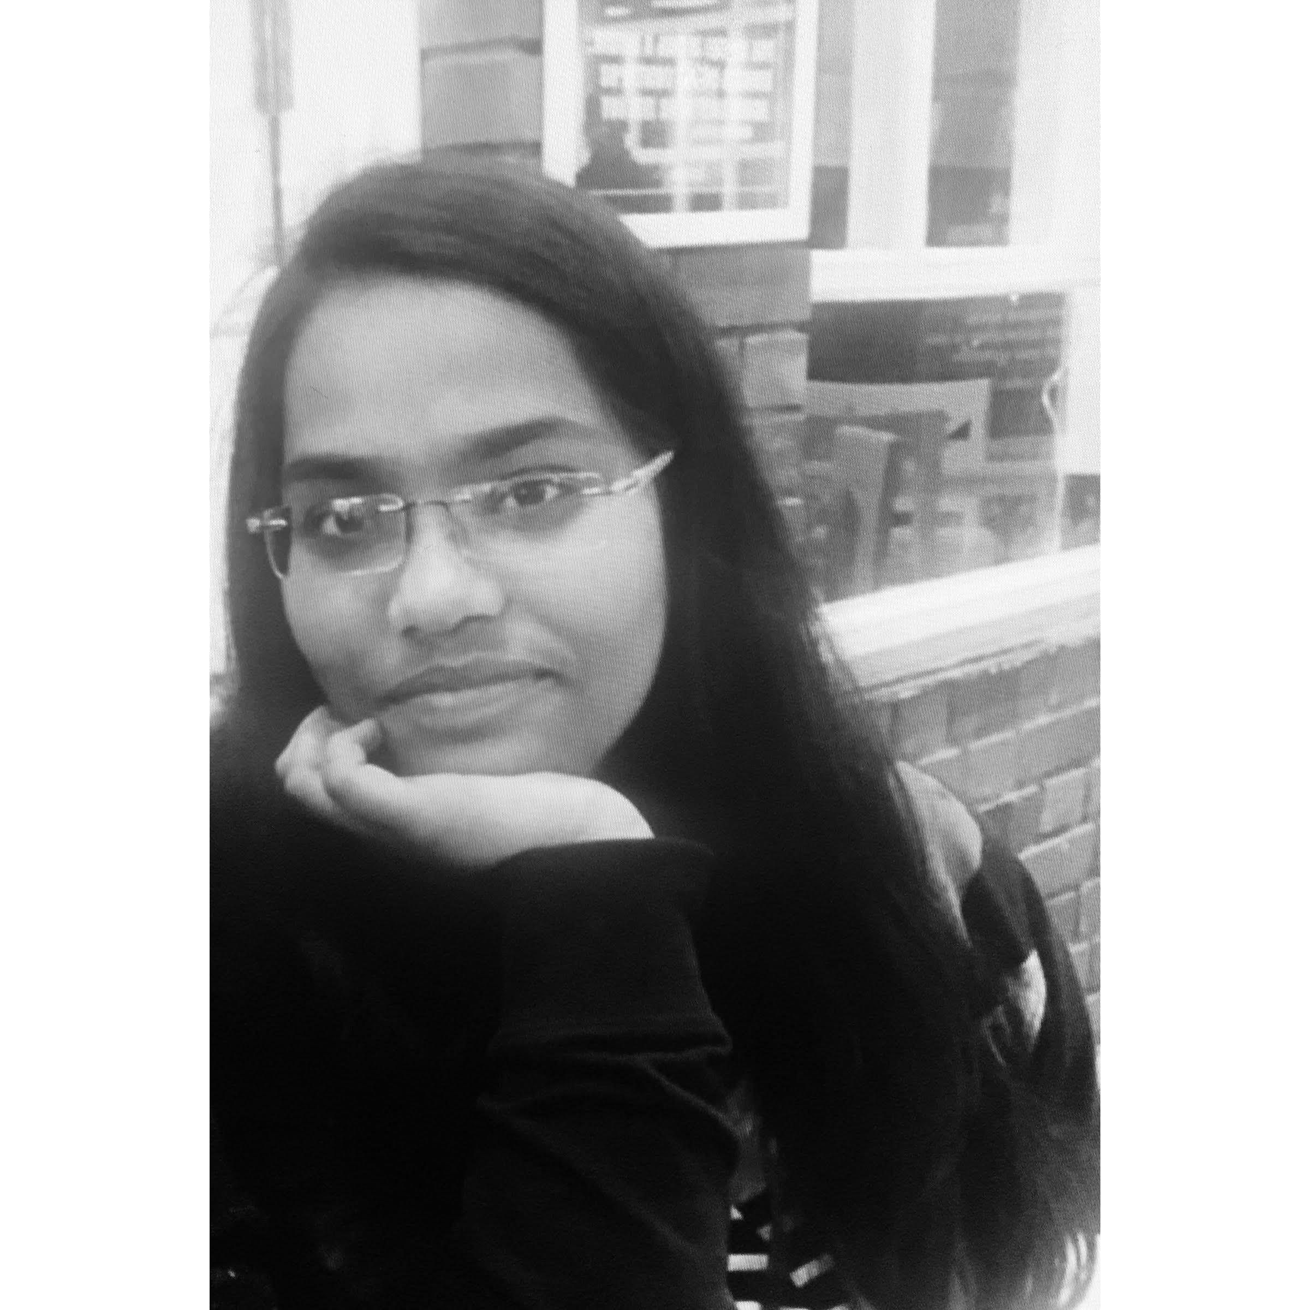

gayatri nagar, Vijayawada, Andhra Pradesh-520008.

**Phone**: **+91** 6303886992

**Email**: [kanikantiharshitha@gmail.com](mailto:kanikantiharshitha@gmail.com)

**LinkedIn:** [**linkedin.com/in/harshitha-kanikanti-0944b618**](https://www.linkedin.com/in/harshitha-kanikanti-0944b618)

**Github:** [github.com/harshitha123kanikanti](https://github.com/harshitha123kanikanti)

|  |
| --- |
| **Career Objective** |

Secure a responsible career opportunity to expand my skill set and use them in solving real life problems and to be the part of a reputed organization that provides steady career growth, challenges to work on and give a valuable contribution to the success of the organization.

|  |
| --- |
| **Academic Background** |

|  |  |  |  |
| --- | --- | --- | --- |
| **Year(s)** | **Qualification – Degree** | **Board/University** | **Percentage / CGPA** |
| 2018-2022 | B. Tech in Computer Science Engineering- Specialization in Big Data | University of Petroleum and Energy Studies | 7.97/10  (*Till end of VIth semester) |
| 2016-2018 | XII | Andhra Pradesh Board of Intermediate Education | 9.1 |
| 2015-2016 | X | Andhra Pradesh Board of Secondary Education | 9.5 |

|  |
| --- |
| **Internships and Projects** |
|  |

|  |  |
| --- | --- |
| **Company:**  **Position:** | Foxmula-The Smart Way  **SDE Intern** |
| **Description:** | Worked on an E-commerce website which would help students during their study time. Being a scrum master, I am responsible for managing my team and creating the front end of cart module according to the requirements needed. |
| **Duration:** | May 2021- July 2021 |

|  |  |
| --- | --- |
| **Company:** | UPES (Minor Project) |
| **Project Title:** | **Comparison of page replacement algorithms** |
| **Description:** | In this project we worked on the comparison between **FIFO, LRU** and **optimal** page replacement algorithms in C programming language on the basis of page faults. |
| **Duration:** | Aug 2020- Dec 2020 |

|  |  |
| --- | --- |
| **Company:** | Front end project |
| **Project Title:** | **Personal Portfolio** |
| **Description:** | Personal portfolio is created using HTML, CSS and JS. It contains information related to me, resume to download and is created visually attractive. Link is provided in the Github. |
| **Duration:** | Jan 2021- Mar 2021 |

|  |
| --- |
| **Online Certifications** |

* Successfully accomplished online certification Intro to **SQL** in February 2021 through Kaggle.
* Successfully accomplished online certification in **Object Oriented Programming** from University of California San Diego in April 2020 through Coursera.
* Successfully accomplished online certification in **Front End Web development** from Freecodecamp in May 2020.

|  |
| --- |
| **Co-Curricular Activities/Achievements** |

* Achieved gold badge in **Java, Python** from **Hackerrank.**
* Recipient of **Education Outreach Scholarship 2021** by **GirlScript Foundation.**
* Passed **Python for data science** exam on cognitive.io by **IBM.**
* Helped women in an **NGO** (Vasavayya Mahila Mandali) on teaching them how to use electronic gadgets and made them become confident.
* Core-committee member of CSI Student Chapter- Helped in organizing events and worked as a photographer.

|  |
| --- |
| **Skills** |

* **Coding Languages:** Java, Python, MySQL, HTML, CSS
* **Soft Skills:** Adaptive personality, willingness to learn, patience
* **IDE:** Eclipse, Jupyter notebook, Visual Studio code, Dev C++

I hereby declare that the information stated above is true to the best of my knowledge.

**Name of the Student:** Kanikanti Harshitha